KCH1 -

Functionality
A profit center group is a hierarchical structure of profit centers.
You can use profit center groups to group profit centers together according to company-specific criteria. Profit center groups are used for reporting, allocations or in various planning functions, where it does not make sense to enter or display data at the lowest level (with a high level of detail).

Scenario
This transaction is used to create a Profit Center Group.

Menu Path | Accounting → Controlling → Profit Center Accounting → Master Data → Profit Center Group → KCH1 - Create
Transaction Code | KCH1

1. Double Click on KCH1 – Create.

Create Profit center group: Initial Screen

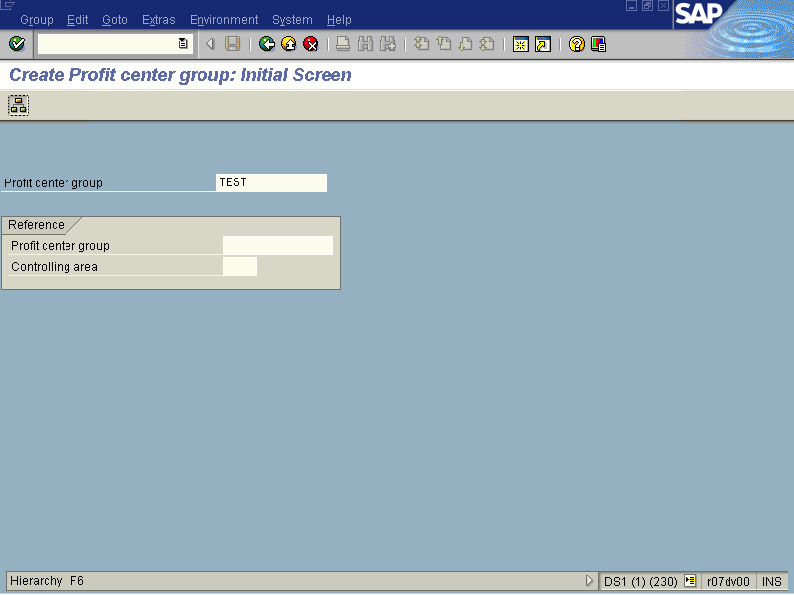

2. Update the following fields:

Field Name | Field Description | Values
Profit center group | Is a grouping of profit centers in the Standard Hierarchy. | Example: TEST

3. Click Display menu of an activity group Shift+F5 Button .

Create Profit center group: Structure

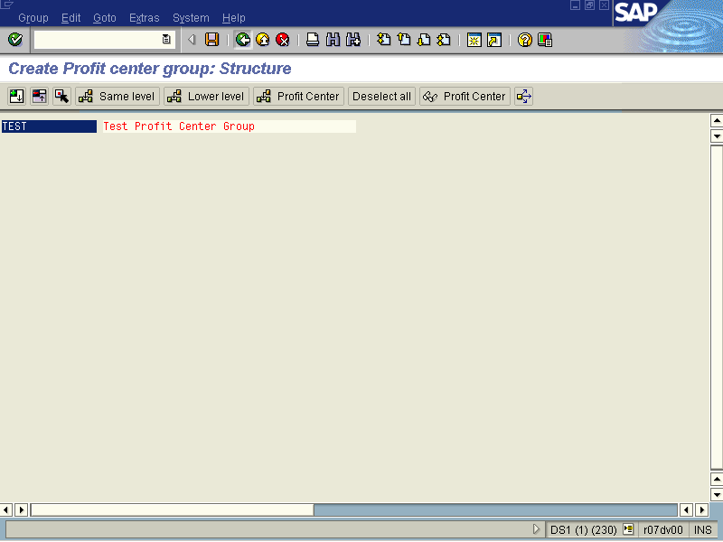

4. Update the following fields:

Field Name | Field Description | Values
Name | Name of the profit center . | Example: Test Profit Center Group
Description | Description of the profit center | Example: Test
5. Click Enter to validate the entry.
6. To assign profit centers to the group, click on the button once.
7. Click the Profit Center button to add individual profit centers to the group.

Create Profit center group: Structure

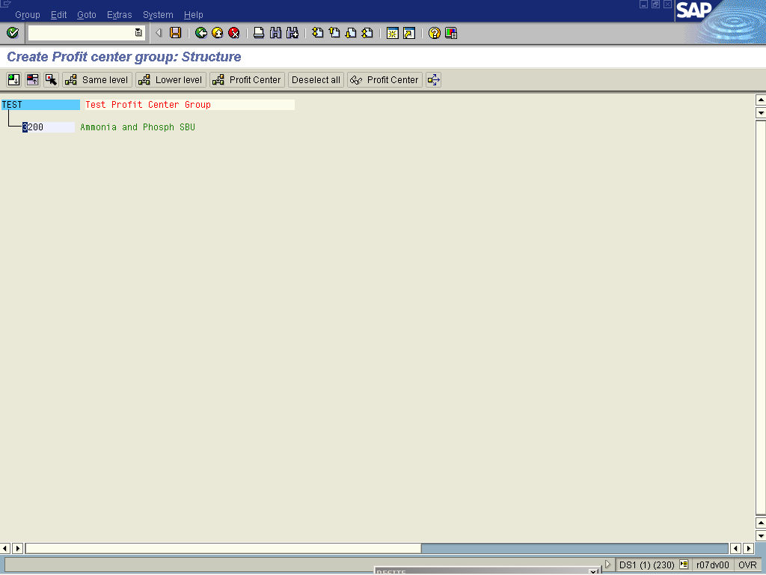
8. Update the following fields:

Field Name | Field Description | Values
Number | Number of the profit center. | Example: 3200 Ammonia

9. Once all the relevant profit centers have been assigned to the group, click on the Save button.

Create Profit center group: Structure

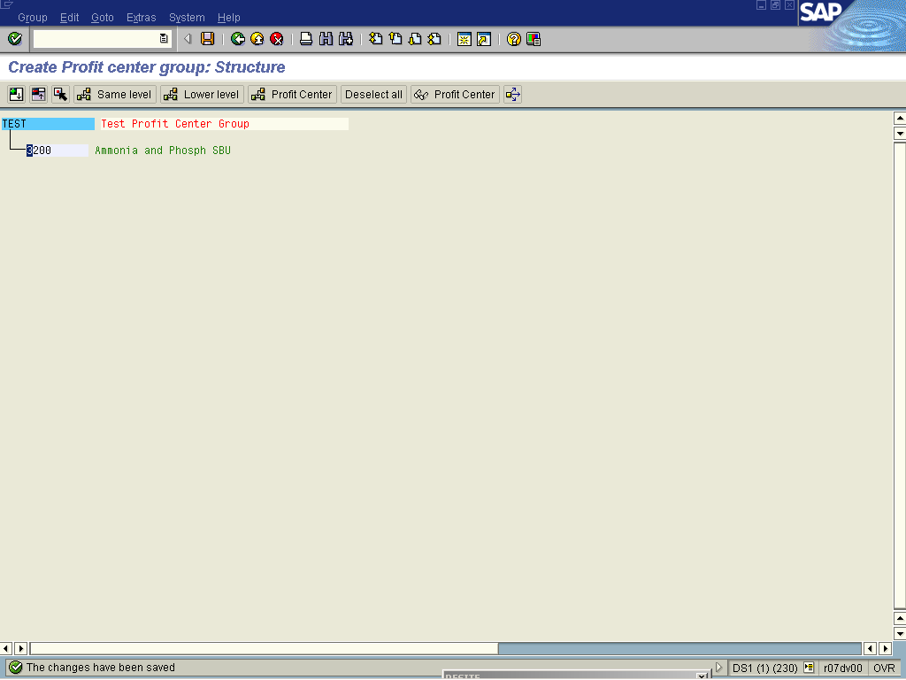

10. The message bar displays “The changes have been saved”

